CA-6: As a clinic staff, I want to record a patient's consultation, so that I can properly document the patient's diagnosis, treatment plan, and prescribed medicines for accurate patient records and inventory management.

Rationale
This documentation focuses on the design and development of the consultation recording feature of the clinic desktop application for clinic staff. It aims to provide a reliable way to document a patient’s diagnosis, treatment plan, and prescribed medicines in the patient’s medical record. When a prescription is saved, the system checks the available medicine stock and deducts the prescribed quantity, so the clinic’s inventory stays accurate. To be user-friendly, the system gives clear feedback when the stock is insufficient and prevents the prescription from being processed.
Scope of Work

Business Value
System Architecture
The desktop application (e.g., built using Java SE) will utilize a standard tiered architecture to separate the user interface from business logic and data access.
- Presentation Layer (UI): The ConsultationForm screen where clinic staff enter the diagnosis, treatment plan and prescription and view saved consultations. It performs preliminary validation to ensure required fields are filled in before calling the service.
- Business Logic Layer (ConsultationFacade): Validates the consultation, checks the available stock, saves the consultation and prescriptions, deducts the prescribed quantity from the inventory, and commits or rolls back everything as one transaction. It throws InsufficientStockException when the stock is not enough.
- Data Access Layer (DAO): Manages the connection and queries to the database for consultations, prescriptions and inventory items.
- Database: Stores the persons, students, staff, medical records, consultations, prescriptions, medicines and inventory stock.

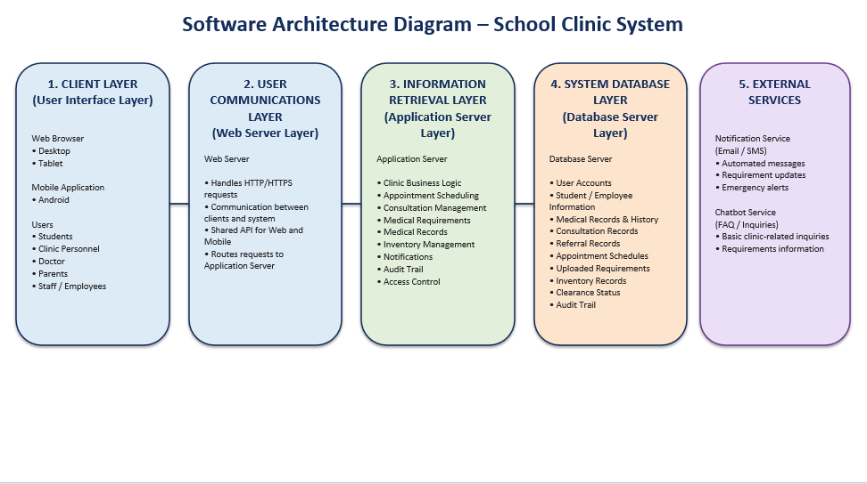

Data Models

Use Case Diagram

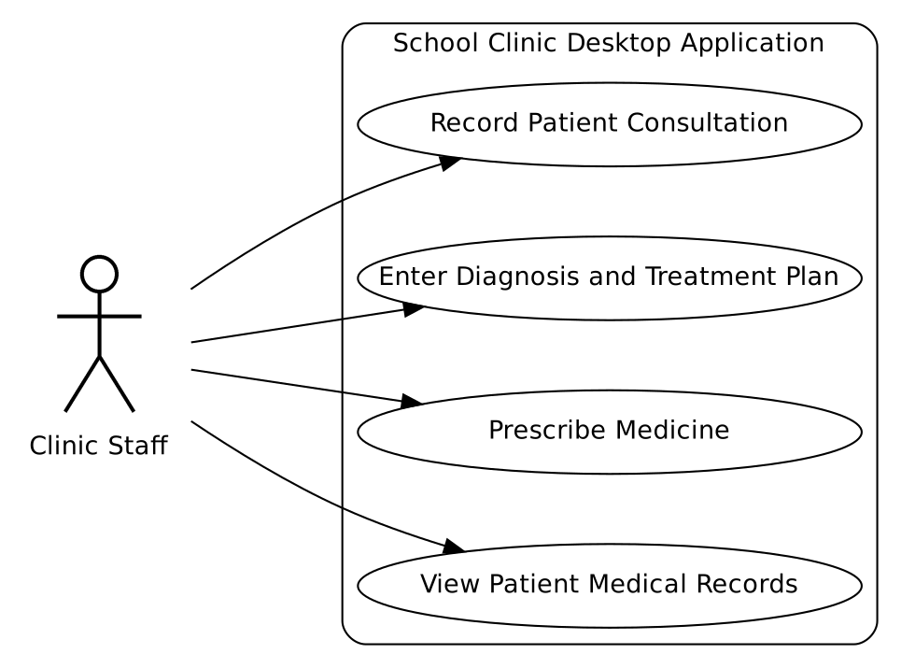

Activity Diagram
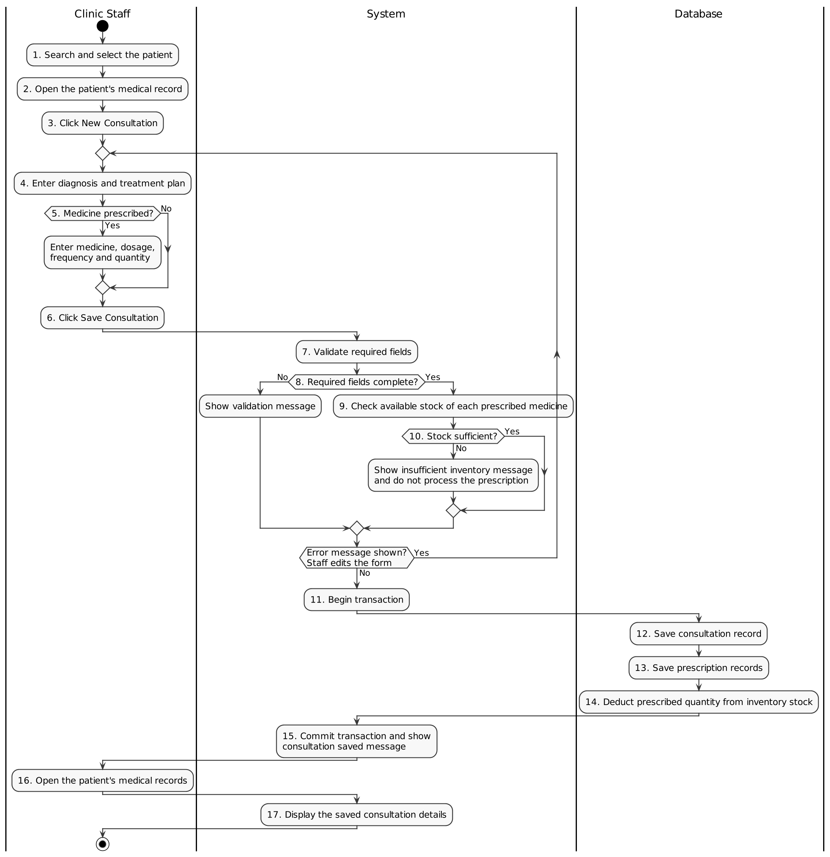

Sequence Diagram(Save consultation)

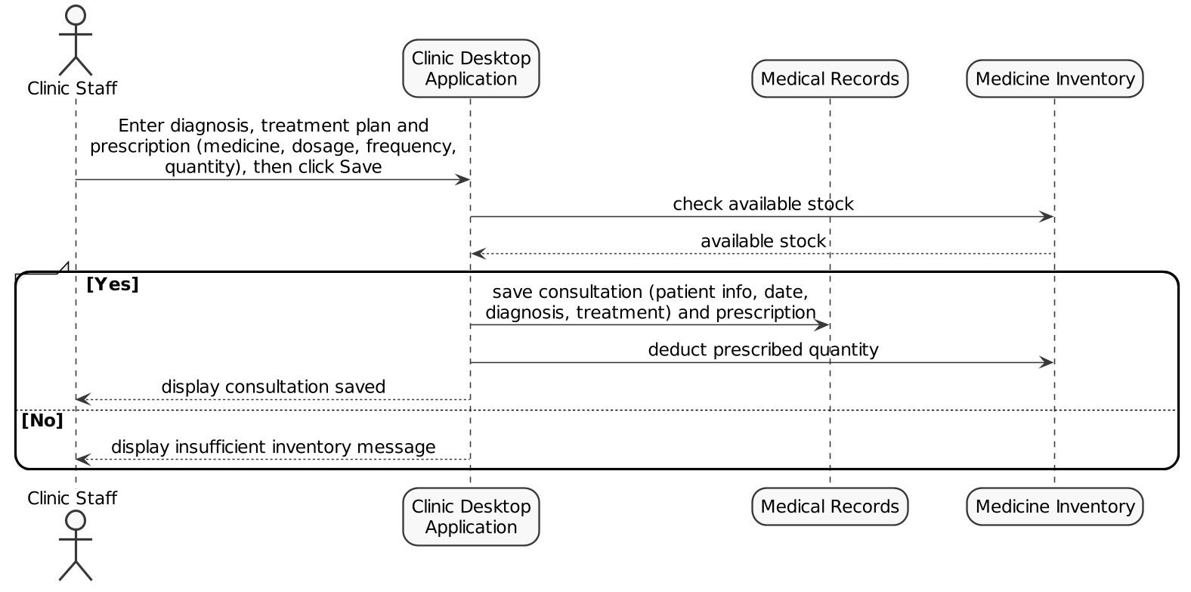

Sequence Diagram(View consultation)
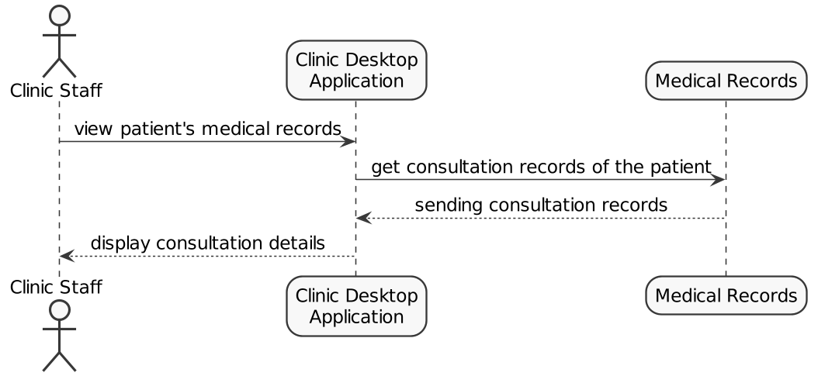

Entity Relationship Diagram
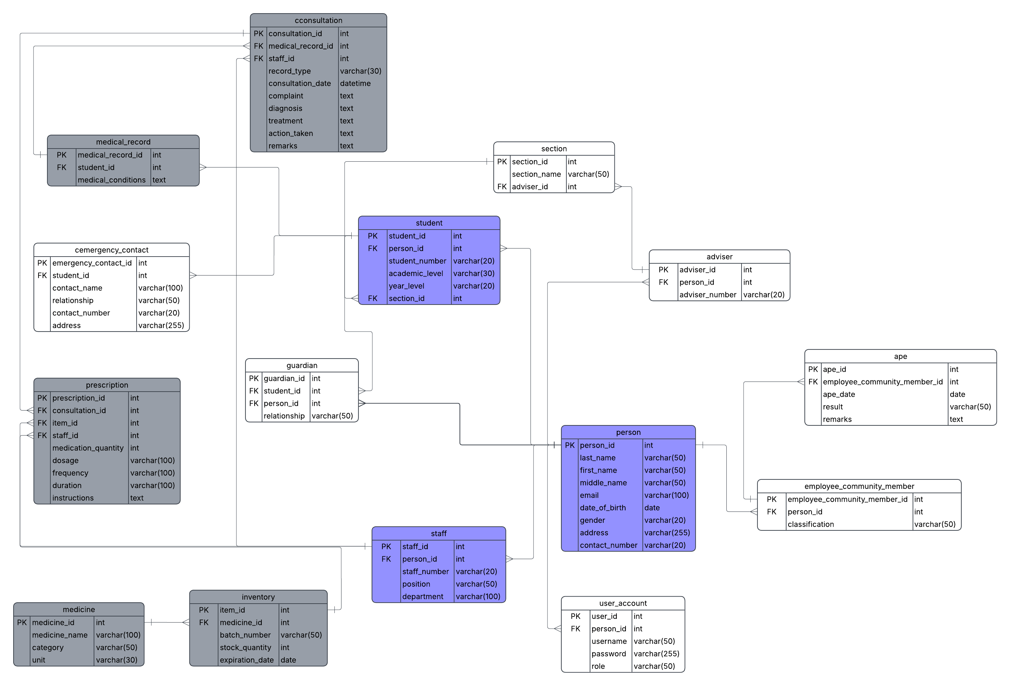

Database Design

Table 1, Person table
Field name | Data type | Description
person_id | INT | Auto-generated unique identifier for the person.
last_name | String | Person's last name.
first_name | String | Person's first name.
middle_name | String | Person's middle name.
email | String | Unique email address of the person.
date_of_birth | DATE | Person's date of birth.
gender | String | Person's gender.
address | String | Person's home address.
contact_number | String | Person's contact number.

Table 2, Student table
Field name | Data type | Description
student_id | INT | Auto-generated unique identifier for the student.
person_id | INT | References the person record linked to this student.
student_number | String | Unique student identification number.
academic_level | String | Academic level of the student (ex, Elementary, Junior High, Senior High, College).
year_level | String | Year or grade level of the student.
section_id | INT | References the section the student belongs to.

Table 3, Staff table
Field name | Data type | Description
staff_id | INT | Auto-generated unique identifier for the staff record.
person_id | INT | References the person record linked to this staff member.
staff_number | String | Unique staff identification number.
position | String | Staff member's job position or title.
department | String | Department where the staff member is assigned.

Table 4, Consultation table
Field Name | Data Type | Description
consultation_id | INT | Auto-generated unique identifier for the consultation.
medical_record_id | INT | References the medical record associated with the consultation.
staff_id | INT | References the staff member who handled the consultation.
record_type | String | Type of consultation record (e.g., Check-up, Emergency).
consultation_date | DATETIME | Date and time the consultation took place.
complaint | String | Patient's reported complaint or symptoms.
diagnosis | String | Diagnosis given during the consultation.
treatment | String | Treatment provided during the consultation.
action_taken | String | Action or actions taken by the staff member.
remarks | String | Additional notes or remarks about the consultation.

Table 5, Medical Record table
Field name | Data type | Description
medical_record_id | INT | Auto-generated unique identifier for the medical record.
student_id | INT | References the student who owns this medical record.
medical_conditions | String | Description of the student's known medical conditions.

Table 6, Medicine table
Field name | Data type | Description
medicine_id | INT | Auto-generated unique identifier for the medicine.
medicine_name | String | Name of the medicine.
category | String | Category or classification of the medicine.
unit | String | Unit of measurement for the medicine (ex, tablet, ml, bottle).

Table 7, Prescription table
Field Name | Data Type | Description
prescription_id | INT | Auto-generated unique identifier for the prescription.
consultation_id | INT | References the consultation during which the prescription was given.
item_id | INT | References the inventory item or batch prescribed.
staff_id | INT | References the staff member who issued the prescription.
medication_quantity | INT | Quantity of medication prescribed.
dosage | String | Prescribed dosage amount.
frequency | String | How often the medication should be taken.
duration | String | Length of time the medication should be taken.
instructions | String | Additional instructions for taking the medication.

Table 8, Inventory table
Field name | Data type | Description
item_id | INT | Auto-generated unique identifier for the inventory item.
medicine_id | INT | References the medicine associated with this inventory batch.
batch_number | String | Batch number of the medicine stock.
stock_quantity | INT | Current quantity of the medicine in stock.
expiration_date | DATE | Expiration date of the medicine batch.

Interface Specification
The ConsultationForm screen is used by clinic staff to record a patient's consultation and to view the patient's consultation history. It contains the following elements:
- Patient Information: Read-only labels showing the name and student number of the selected patient. This is saved with the consultation.
- Consultation Date: Date and time of the consultation. Filled in with the current date and time and shown as read-only.
- Record Type: Drop-down list for the type of consultation (e.g., Check-up, Emergency).
- Complaint: Multi-line text input for the patient's reported complaint or symptoms.
- Diagnosis Field: Multi-line text input for the diagnosis. Required.
- Treatment Plan Field: Multi-line text input for the treatment plan. Required.
- Action Taken and Remarks Fields: Optional multi-line text inputs.
- Prescription Table: A table where staff add one row per prescribed medicine. Each row has a Medicine drop-down (showing the available stock), a numeric Quantity field, and text fields for Dosage, Frequency, Duration and Instructions.
- Add Medicine and Remove Medicine Buttons: Add a new row to, or remove the selected row from, the Prescription Table.
- Save Button: Triggers the save workflow: validates the required fields, checks the available stock, saves the consultation and prescriptions, and deducts the prescribed quantities from the inventory.
- Clear Button: Empties the form without saving.
- Message Container: A designated UI element (e.g., a text label below the buttons or a pop-up dialog) that displays validation messages, the insufficient inventory message, the failed message, and the consultation saved message.
- Consultation History Table: A read-only table in the patient's medical record listing the saved consultations (date, record type, diagnosis, treatment and prescribed medicines). Selecting a row shows the full consultation details.

Component Specification
Component | Description
Consultation | Model class containing consultation_id, medical_record_id, staff_id, record_type, consultation_date, complaint, diagnosis, treatment, action_taken, and remarks.
Prescription | Model class containing prescription_id, consultation_id, item_id, staff_id, medication_quantity, dosage, frequency, duration, and instructions.
ConsultationDao | DAO interface that specifies an insert method with a Consultation parameter and a findByMedicalRecordId method that accepts a medical record ID.
ConsultationDaoImpl | Implementation of the ConsultationDao interface that handles database operations for consultation records.
PrescriptionDao | DAO interface that specifies an insert method with a Prescription parameter and a findByConsultationId method that accepts a consultation ID.
PrescriptionDaoImpl | Implementation of the PrescriptionDao interface that handles database operations for prescription records.
ConsultationFacade | Service interface that specifies the saveConsultation method, which accepts a consultation and a list of prescriptions, and the getConsultationsByMedicalRecord method that accepts a medical record ID.
ConsultationFacadeImpl | Implementation of the ConsultationFacade interface. It validates the required fields, checks the available stock for each prescribed medicine, saves the consultation and prescriptions, deducts the prescribed quantities from the inventory, and commits or rolls back all changes as one transaction.
InsufficientStockException | Custom exception thrown by the ConsultationFacadeImpl when the prescribed quantity is greater than the available stock. The Desktop displays an insufficient inventory message and nothing is saved.
ConsultationForm | Desktop screen where clinic staff enter the diagnosis, treatment plan and prescription, click Save, and view the consultation history in the patient's medical records.
Staff | Shared model class containing staff_id, person_id, staff_number, position, and department. The staff_id of the logged-in staff is saved with the consultation and prescription.
MedicalRecord | Shared model class containing medical_record_id, student_id, and medical_conditions. Identifies the patient's medical record that the consultation belongs to.
Student / Person | Shared model classes for the student (student_id, person_id, student_number, academic_level, year_level, section_id) and the person (name and contact details). Used to display the patient's information.
Medicine | Shared model class containing medicine_id, medicine_name, category, and unit. Used to display the medicine name in the prescription.
InventoryItem | Shared model class containing item_id, medicine_id, batch_number, stock_quantity, and expiration_date.
InventoryDao / InventoryDaoImpl | DAO interface and implementation from the inventory stories. This story uses only the findById method (accepts an item ID) to read the available stock and the deductStock method (accepts an item ID and a quantity) to reduce stock_quantity.

